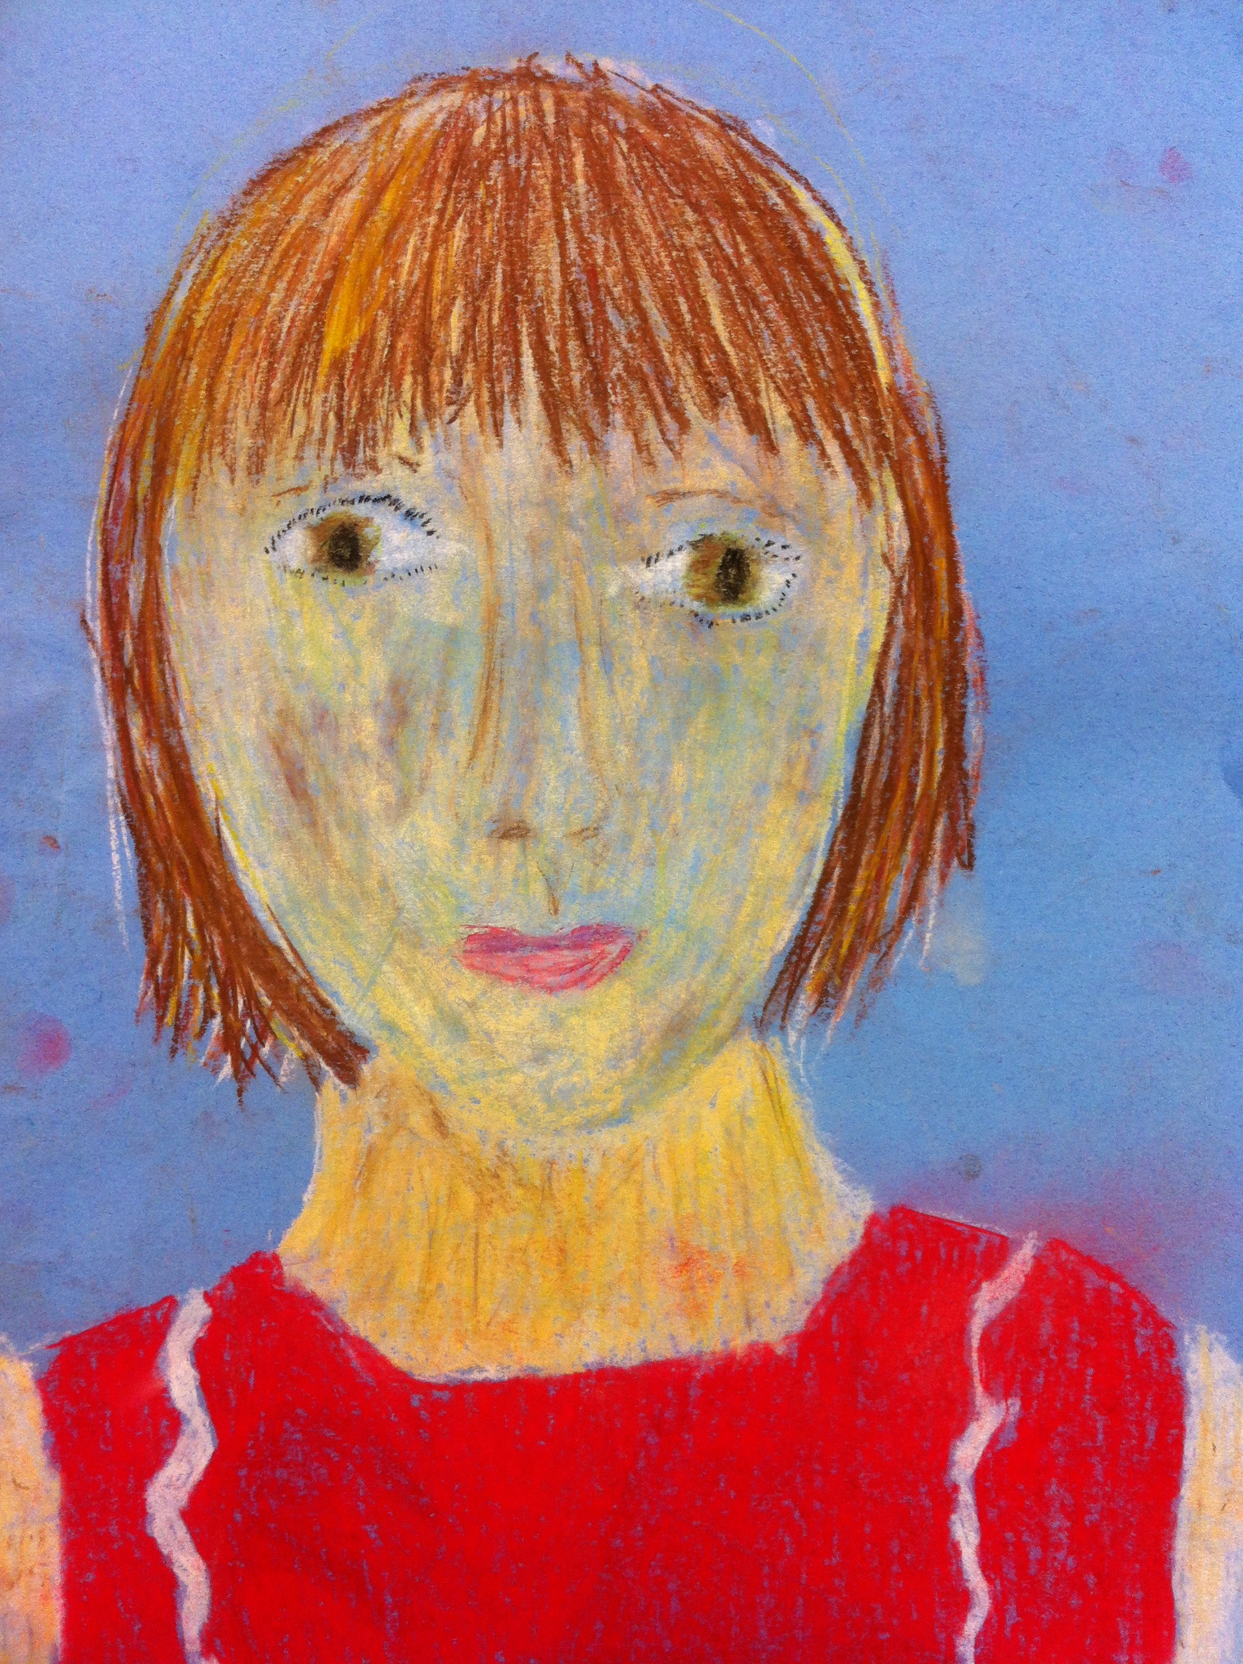
Ms. Chown

Essential question:
Who are we and how do we fit together?

Knowing me, knowing you…
Dear new fourth grader and your family,

The Knowing Me, Knowing You begins at the start of our fourth grade journey. Through drafts, critique, and fun we will lay the foundations of Room 15: the class who are resilient, who learn and laugh together and the class who embrace challenges in order to produce high quality work.

As we draw our self-portraits, research how our bodies work, and use science, writing and math to investigate different ways that we are connected, we will learn more about ourselves and each other.

The job of a fourth grader is to look again at what you think you already know and, in the process, deepen your understanding. Throughout this project we will learn new skills, use new tools and, importantly, make new friends. I can’t wait to get started!

Love,

Ms. Chown

Throughout the project, we will also discuss and answer (where possible) the following questions:

- What are we made of?
- What is our life story and what are the life stories of those around us?
- How is our story connected to the stories of others?
- How have we changed over our lives?
- How are we connected to other people?
- How can math help us discover more about ourselves?
- What is anthropology and what do anthropologists do?
- How can we improve our work?
- How can we help others to improve their work?

We will read:
- Biographies of artists, musicians, naturalists, scientists and athletes and more
- Magazines filled with facts about how our bodies work
- Each other’s work in order to learn about each other and to improve our own work.

The math we will need for this project:
- Data
- Averages
- Measurement

We will make:
- A self-portrait using chalk pastels (individual)
- A biography of a partner (individual)
- An infographic to tell a data story about our class (pairs)
- An expert guide to something that we can teach others (individual)
- An anthropology journal connecting all of our learning (whole class)

Also we will:
- Create exhibition invitations (table group)
- Plan out our exhibition (whole class)
- Write daily reflections to help us understand our learning and how it is meaningful to us (individual)

Who will I/my child work with?
In this project, you will work by yourself and with a variety of partners. You will have a biography partner, a writing partner and a research partner. This will help you to get to know more about the people in our class as well as discovering more about you as a learner and a 4th grade student.

Critique, redrafting and challenge
This project introduces multiple drafts and critique in our classroom. In order to create our self-portrait, we will follow a structured draft process. We will offer critique that is kind, specific and helpful and we will learn how to use this critique to make improvements in our work. As well as student-to-student critique, Ms. Chown will ask us questions designed to help us think deeply about our learning and the choices that we make.

Within this project, we will link up with Ms. Zimmer’s 5th grade class in order to offer our critique on their poetry. In turn, they will critique our self-portraits and writing. This collaboration will help us learn more about the writing and critique process, and ourselves.

Every piece of work that we complete is designed to contain challenges for every child in the class – because only when we push ourselves, are we truly learning. To help us meet the challenges, we will look at examples of work, completed by experts or other children. We will use these models to help us create our own rubrics.

Exhibition
Our exhibition will help other people understand the connections around them. Our exhibition will also show that fourth graders are capable of producing work of an extremely high standard. It will be a celebration of everything that we have achieved.

More information:
If you would like to find out more about the books we will be reading, the experts that we will be working with or you would like to come along and help at any point in our journey, please get in touch. I am available most days after school or you can email me at bchown@explorerelementary.org

Check out our website and our blog (http://eeroom15.weebly.com) to follow the progress of our project.

