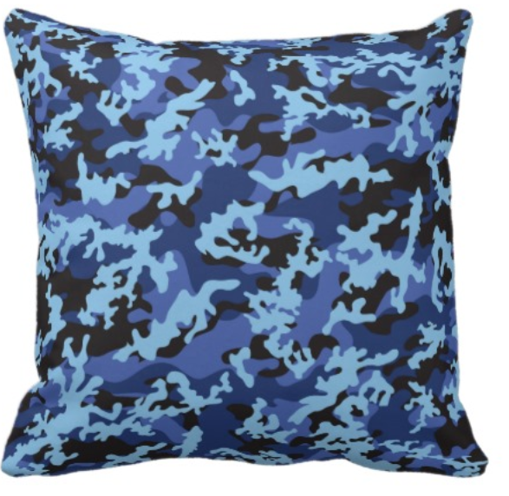
Operation: Story Cushion

A fourth grade community project.

Essential question: how can we make a difference in our city?

San Diego is home to many military families. According to Navy Dispatch (http://www.navydispatch.com), 69 Navy ships call San Diego home and almost 90,000 Navy personnel live in San Diego County. That means there are a lot of children in our school and our neighborhoods whose parents are in the military.

When a parent in the military is deployed, they may need to leave home for several months. Although this year we don’t have any military families in our class, I know that you can use your imagination to understand how this might feel. Imagine if one of your parents had to leave for a long time. Imagine if you couldn’t talk to them or get a hug from them when you wanted. Imagine how frustrated and sad this would make you feel.

The good news is that we can do something to help. We can’t magic our friends’ parents back, but we can help them hear their voices and we can give them something to hug. In short, we can make them a…

Story cushion!

“What,” I hear you ask, “is a story cushion?” Great question. You have never heard of story cushions because, until now, they have never been invented!* A story cushion is a custom made cushion for a child with at least one military parent. The cushion is not only beautifully made but it also contains a small audio device that allows children to press a button and hear their parent’s voice, whenever they like. Depending on what the child wants, the parent may have recorded a goodnight message, a special family story or a simple, but important “I love you.”

* as far as I know!
Important questions we will answer:
- How are memories/stories important in our lives?
- What is empathy? How is it different from sympathy?
- What actions can we take to create a better world?
- What makes a successful interview?
- How do interviews help us learn?
- How can technology connect us?
- How can we develop our hand and machine sewing skills?
- How can we use groups to support our work?
- What makes an effective letter?
- How can we write and present a speech that connects with our audience?
- How can we raise money?
- What is a budget and how do we manage one?
- How can we plan an event that everyone will want to come to?
- How can writing help us to remember events and better understand our feelings and wonderings?
- What is the role of the military in San Diego?

What will we make?
We are aiming to make one cushion per student. However, if we find that there is a high demand for cushions, we’ll make more.

Each cushion will arrive with a handwritten note from the student who made it, explaining the design decisions that they made, what was challenging about making the cushion and what they most enjoyed.

In addition, we will plan a party or a ceremony for our exhibition. This will be a celebration of the project and will be an opportunity for us to give our cushions to the families who wanted them. In order to do this we will need to manage a budget, prepare food and plan games.

Finally, we will write a speech focusing on a time when we have missed someone in order to help us develop empathy with those who have requested a cushion. We will give these speeches at exhibition.

How long will this project last?
Operation story cushion will last at least 8 weeks, but if we find that lots of people want the cushions, then we can be flexible and extend the project so that we don’t need to turn anyone down.

“But Ms. Chown…”

“I can’t sew!”
You can’t sew YET! As you know, when you are prepared to work hard and set your mind to something, you can achieve it. In addition, we are lucky to be working with sewing experts including Ms. Carrie!

“Giving a speech at exhibition sounds terrifying. Do I have to do it?”
My aim is that everyone will give a speech, even if it means stepping out of their comfort zone. However, no one will be forced to do it. Everyone will write a speech but there may be an option to record it rather than say it on the day.

“Can you be more exact about what our exhibition will look like?”
In a word: no! You have now taken part in two fourth grade exhibitions that we have planned together, but this one is up to you. What will be the most fun event for the families we are working with? What can we afford? What can we make for it? The choice, and the responsibility is yours!

“Who am I going to work with?”
There are lots of different ways that we will work together on this project. We will work in pairs, by ourselves and in small groups. It will depend on what part of the project we are working on. For example, you will make one cushion each (or in some instances, you might want to work in a pair to make a cushion). However, you will have a support group that you can go to for help with sewing as well as with writing the letters and the speeches. Some decisions (such as the exhibition) will need to be made by the whole class but small teams will be in charge of the different parts of the exhibition.

“I think this sounds like a great project Ms. Chown!”
Thank you, I think we are all very excited about it!

If you have any questions about the project, or if you just want to find out more about life in Room 15, check out our class website eeroom15.weebly.com or email me, Briony Chown at bchown@explorerelementary.org

