Operation: story cushion
time line
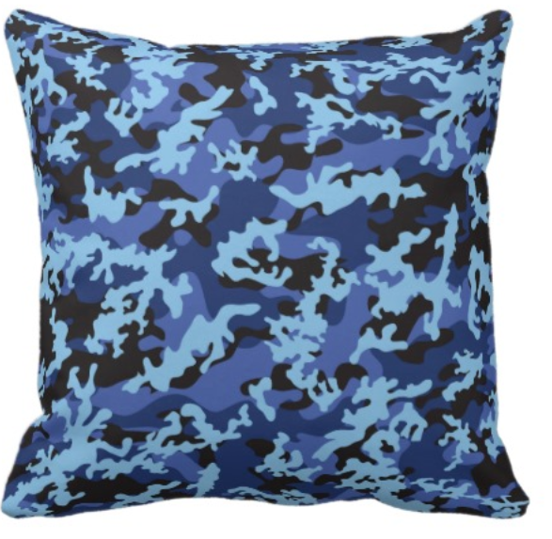
Week 1 (starting on Tuesday, March, 10th)
- Interviews with a Marine, a member of the Navy and a college student whose dad was in the Marines. Begin to understand what it is like for families to have to live apart during deployment?
- Reflection – how did we connect with this interview? What do we feel at the start of this project?
- Front cover of reflection journals – start to think about what you cushion might look like and say.
- Family trees – start to think deeply about your own family by creating a close family tree with written descriptions of different family members. You can use paper cutting or drawing to create the tree
Week 2
- The importance of memories – class discussion in concentric circles. Think about what memories are important to you and to your family by talking about them to others in the class. Practice engaging listening and speaking skills. Discuss - what makes something into a memory.
- Practice interviewing (especially listening and asking follow up questions) by asking our High Tech Middle buddies about their special memories. This will help us interview children we don’t know on Thursday.
- Create a list of questions to ask the children we will be making the cushions for. These interview questions will help us to get to know them.
- Test our interview questions. Can we use them to help us to design a cushion for a classmate?
- Interview K-5th grade students at Dewy Elementary. We will use this information to make cushions for them.
- Sewing skills with Ms. Carrie: threading a needle, stitching by hand in a straight line with small even stitches (running, back and blanket stitch).
- Reflections – how are memories important in my life? How are memories important in my family? Feelings about interviewing the students? What makes a successful interview? What did I learned about my interviewee?
- Homework: interviewing friends or family member about special memories. Take extensive notes on one to write a brief narrative. Ask them for critique.
- Empathy vs. sympathy video

Week 3 (after spring break)
- Begin to publicize cushions to Explorer families. Plan after school meeting.
- Empathy vs. sympathy mini plays
- Sewing skills – use a machine to sew a straight line
- Homework: record your parentin order to create your own mini cushion
- Fundraising interview – each cushion will cost approximately $20. We will interview successful fundraisers to help us to raise this money.
- Create a fundraising action plan.

Week 4
- Field trip to Discount Fabrics to buy fabric and decorations for the project
- Work in pairs to create two mini prototype cushions. Add your recorded family parent memory
- Plan fundraising events
- Sewing workshops with Ms. Carrie.
- Voluntary group - create presentation for Explorer military parent meeting.
Week 5
- Hold parent meeting at Explorer
- Design, critique, redesign and sew cushions
- Begin fundraising events. Use charts and graphs to keep track of our fundraising efforts.

Week 6
- Continue to sew cushions.
- Evening of 29th April – interview parents at Dewey Elementary in order to make the cushions.
- Reflection: as we design and sew, we will make time at morning and closing meetings to discuss what is going well, what we need help with and what we can help others to do.
Week 7
- Draft, critique, revise and complete handwritten letters.
- Plan exhibition celebration
- Apply to exhibition teams (entertainment, location, catering, publicity, video, budget, crafts and decoration)
- Work in teams to plan our event.
Week 8
- Continue to plan exhibition at Dewey
- Project reflection
Week 9
- Exhibition at Dewy Elementary

Weeks 10-12
- Plan exhibition at Explorer
- Final project reflection

The nature of project based learning means that we have the flexibility to do follow our interests and passions within this project. It also means that this timeline may change! Please contact Ms. Chown (bchown@explorerelementary.org) or speak to a Room 15 student for up-to-date information on our project progress.

