How can we combine our knowledge, skills and interests to help a local bookshop?

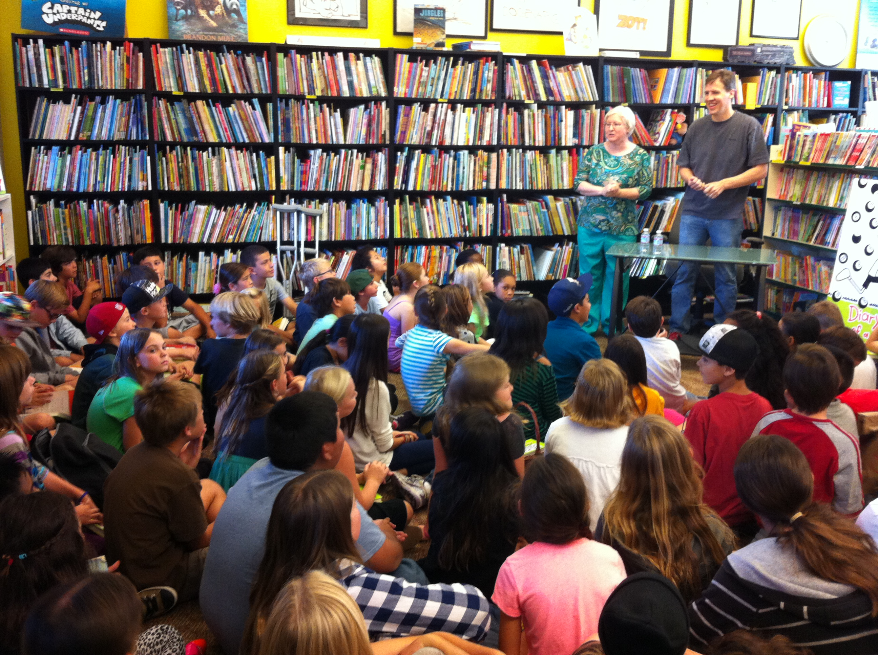
I really love independent bookstores!

We love books… We love animals… We love art… We love science… We love walking to places…

We’ll bring it all together.
On Thursday, November 7th, 2013, we met Jeff Kinney, the author of the world-famous Diary of a Wimpy Kid series. Jeff Kinney was speaking and signing books at Yellow Book Road, a small bookshop in Liberty Station (where our school is). He said many things that stuck in our minds but one thing really got us wondering.

“I really love independent bookstores!”

What is an independent bookstore? Should we love them too? If so, why?

We decided to take these wonderings back to Yellow Book Road, the independent bookstore where we met Jeff Kinney. Here is what we found out.
Equipped with this vital information, we knew we wanted to get involved. So, for this project we will use our knowledge, interests and skills to create something special for Yellow Book Road, something to make this bookshop stand out!

In this project we will answer these questions

Bookstores and libraries
What is the difference between an independent and a chain bookstore?
What do libraries do?
How can we make something that will make more people want to come into Yellow Book Road?

Animals
Why do we like animals so much?
What is life like for different animals?
What problems do these animals face and how do they solve them?
What can we learn from animals?

Story writing
How can we tell the story of our animal?
How can we find information quickly?
What can we magpie from poems and stories?
How can we improve our vocabularies so we can use the best words in our stories?
How can we make it clear when characters in our stories talk to each other?

